

**Translational Pharmacology Group**

Diseases of the Developing World

*Tres Cantos, Spain*

**Study Report**

# Study Title

Oral therapeutic efficacy of PF-06342505, against *Plasmodium berghei ANKA*

# TPG Study Number

1607_TPG_071

# GSK Therapeutic Efficacy Experiment ID

120914_TE_0523

# C.E.E.A. Approved Protocol

Protocol Nº 005 and 31, 01/02/11

# Report Author

Belén Jiménez

Principal Scientist, Therapeutic Efficacy, Malaria group

**Signature: Date:**

# Reviewed and Authorized

Iñigo Angulo

Manager, Therapeutic Efficacy

**Signature: Date:**

# Issue Date

26.11.2012

# Test Facilities

GSK, Diseases of the Developing World, Malaria Support Group, Calle Severo Ochoa 2, 28760-Tres Cantos, Madrid, Spain.

# Personnel in Charge of the Study

**Therapeutic efficacy**

Experiment Conducted by: Belén Jiménez-Díaz, *Principal Scientist*

Study Supervised by: Iñigo Angulo-Barturen, *Chief Scientist*

Experiment performed by: Sara Viera, *Scientist*

Helena Garuti, *Associate Scientist*

Noemí Magán, *Associate Scientist*

Lorena Cortés, *Associate Scientist*

Vanessa Gómez, *Associate Scientist*

# Location of Raw Data, Original Protocols, and Experimental Details

The original report, raw data, protocols, and experimental details pertaining to this study will be held in the GSK Archive and cross-referenced.

Route to experiment:

\\Tcadsntp004.corpnet2.com\esp_tca_ph_area-id-therapeutic_efficacy\Malaria\Experiments_underway\Ongoing\2012_Experiments\120914_TE_0523

The decimal point is a dot throughout the work document.

The decimal point is a comma in the excel worksheet identified as “Experimental data”.

# Summary

The goal of this observational study is to provide a first assessment of the therapeutic efficacy of PF-06342505 against *P. berghei* ANKA. Efficacy is assessed by administering one oral dose (100 mg/Kg) of PF-06342505 per day for four consecutive days and measuring their effect on blood parasitemia by flow cytometry*.* The parameters of efficacy are calculated at day 7 after infection. The pharmacokinetic parameters upon oral administration of PF-06342505 are analyzed by measuring compound levels in serial blood samples obtained during the 23 h period after first dose in all mice of the efficacy experiment. The area under the curve (AUC0-23h) of levels of compound obtained for each mice are used to estimate the potency of PF-06342505.

In the aforementioned experimental conditions PF-06342505 is not efficacious against *P. berghei.*

# Therapeutic Efficacy Protocol

|  |  |
| --- | --- |
| ***Support Group Study No.*** | 1607_TPG_071 |
| ***Therapeutic efficacy study.*** | 120914_TE_0523 |
| ***Applicable protocols*** | AP12967v1: Flow cytometry method  Protocol 120914_TE_0523_Pb: Experimental details.  CEEA Protocols Nº 005 and Nº 031: Comité Etico de Experimentación Animal. |
| ***Risk assessment*** | ***P. berghei* ANKA**  Biosafety level 2  Risk of accidental inoculation with a human pathogen during experiments.  Medical supervision.  PNT: POMAP-17  Only staff with accredited experience participated in the experiment *in vivo*. |
| ***Assay*** | 4-day test |
| ***Nº mice/experimental group*** | n= 3 for PF-06342505 2 mice in vehicle group. |
| ***Mouse strain*** | CD1 ; (Harlan, France) |
| ***Average weight*** | 28.8 g |
| ***Housing conditions***  ***Parasite*** | air-conditioned, 15 air changes per hour; 22 ± 3 ºC; 40 - 70% relative humidity; 12 h light/dark period; accomodation in standard cages in groups of up to five (CD1) with autoclaved dust free corncob bedding (Panlab); fed with γ-irradiated pellet and ultra-filtered water *ad libitum*.  *P. berghei ANKA*. |
| ***Route of infection*** | Intravenous |
| ***Infective dose*** | *P. berghei*: 1.5×106 infected erythrocytes on Day 0 |
| ***Products*** | PF-06342505 |
| ***Vehicles*** | 1.5% Hydroxypropyl methylcellulose and 0.15% Sodium docedyl sulfate (vehicle for PF-06342505). |
|  |  |
| ***Route of administration*** | p.o. |
| ***Volume of administration (ml/Kg)*** | 20 mL/Kg |
| ***Target doses (mg/Kg)*** | **PF-06342505:** 100 mg/Kg. |
| ***Nº doses/mouse*** | 4 |
| ***Administration schedule*** | u.i.d (once a day) starting on day 3 after infection |
| ***Quality control product preparation*** | Yes |
|  |  |
| ***Measurement of parasitemia*** | Flow cytometry (as described in Cytometry Part A 67A:27–36, 2005) |
| ***Sampling parasitemia*** | 2 µL: Days 3, 4, 5, 6 and 7after infection. |
| ***Nº of events counted*** | 5x105 |
| ***Limit of detection (%)*** | 0.05% |
| ***Data analysis***  ***Linked studies*** | Non linear fitting to logistic equation of log10 (% parasitemia at day 7 after infection).  Parameters of efficacy:  Effective dose 90 % (ED90), defined as the dose in mg/Kg that reduce parasitemia at day 7 after infection by 90 % with respect to vehicle-treated mice  AUCED90, defined as the estimated daily exposure that reduces parasitemia from peripheral blood at day 7 after infection by 90% with respect to vehicle-treated mice.  SuG_1022012_PF-06342505: Measurement of compound levels  QC2012_883: Quality control |

# Deviations from Protocols

No deviations.

The experiments described in this report are deemed valid.

# Experiment description

The therapeutic efficacy of PF-06342505, against *P. berghei* is studied using a ‘4-day test’. Briefly, CD1 are infected with 1.5×106 *P. berghei*-infected erythrocytes. Infections are performed by intravenous inoculation. All mice are randomly assigned to their corresponding treatment. The treatment starts at day 3 and finishes at day 6 after infection. Mice are infected with *P. berghei* and treated with PF-06342505 at 100 mg/Kg once a day for four consecutive days. In all cases, parasitemia is assessed in samples from peripheral blood obtained at days 3, 4, 5, 6, and 7 after infection. Peripheral blood samples (25 µl in 25 µl of 0.1% saponine) are taken to measure levels of compound at different times: 0.25, 0.5, 1, 2, 4, 6, 8 and 23 hours after the first administration of PF-06342505. The lysed samples are immediately frozen in dry ice and stored at -80ºC until analysis. Vehicle-treated mice suffer the same blood-sampling regimen. An estimation of the AUC over the first 23h after the first administration is obtained for each mouse treated with PF-06342505.

A qualitative analysis of the effect of treatment on *P. berghei* is assessed by microscopy and flow cytometry. Fresh samples of peripheral blood from *P. berghei*- infected mice are stained with YOYO-1 (nucleic acid dye) and then acquired by flow cytometer (FACSCalibur, BD). Microscopy analysis is performed with Giemsa-stained blood smears from samples taken at days 5 and 7 (48 and 96 h after starting treatment, respectively).

# Results

## *Pharmacokinetic analysis*

The pharmacokinetic parameters of PF-06342505, upon oral administration are analyzed by measuring compound levels in serial blood samples obtained during the 23 h period after first dose in all mice of the efficacy experiment. The area under the curve (AUC0-23h) of PF-06342505 in blood of each individual mice of the efficacy experiment is used to estimate the amount of product in blood (*Figure 1* and *Table 1*).

## *Parameters of efficacy*

The therapeutic efficacy of PF-06342505 against *P. berghei* in a ‘4-day test’is shown in *Figure 2.*

In the *Pfalc*HuMouse the treatment with PF-06342505 at 100 mg/Kg is able to clear *P. falciparum* at day 5 after infection. However, 100 mg/Kg of PF-06342505 has not any effect against *P. berghei*.

At 100 mg/Kg dose level and comparable exposure, PF-06342505 is significantly less efficacious against *P. berghei* than against *P. falciparum*. (*Table1).*

## *Effect of treatment on parasites*

PF-06342505 doesn´t significantly inhibit parasite growth. This explains the high parasite density, the reduction of reticulocytes and the presence of mature erythrocytes containing healthy rings, trophozoites and mature schizonts (*Figure 5*).

## *Quality control*

*Product preparation quality control*

The concentrations of formulations prepared are measured as quality control of the experiment. The experimental concentrations show a deviation < 10% with respect to target concentrations. So, target doses are used for calculation of efficacy parameters of PF-06342505.

# Conclusion

In the aforementioned experimental conditions, indicate that there is a marked difference in sensitivity between *P. falciparum* (very sensitive) and *P. berghei* (no sensitive) to treatment with PF-06342505.

## **Figure 1. Whole blood levels of PF-06342505 after the first dose of treatment**. Data are individual profiles of PF-06342505 blood concentration *versus* time (0-23 hours).



## **Figure 2. *In vivo* therapeutic efficacy of PF-06342505.** Parasitemia in peripheral blood of mice infected with *P. berghei*. Data are the individual parasitemia for mice treated with PF-06342505 and mean ± SEM of n=3 mice for vehicle group.

Red symbols: Data obtained for the dose of 100 mg/Kg of PF-06342505 in the previous experiment with *P. falciparum*.

ED90 line: represent the reduction of *P. berghei* parasitemia by 90 % with respect to vehicle-treated.

Limit of detection for *P. berghei* and *P. falciparum*: a and b lines respectively.



## Figure 3. The effect of **PF-06342505** treatment on *P. berghei* *in vivo*. A) Peripheral blood smears stained with Giemsa. B) Flow cytometry dot plots from samples of peripheral blood stained with YOYO-1. Dots inside the polygonal region represent *P. berghei*-infected erythrocytes.

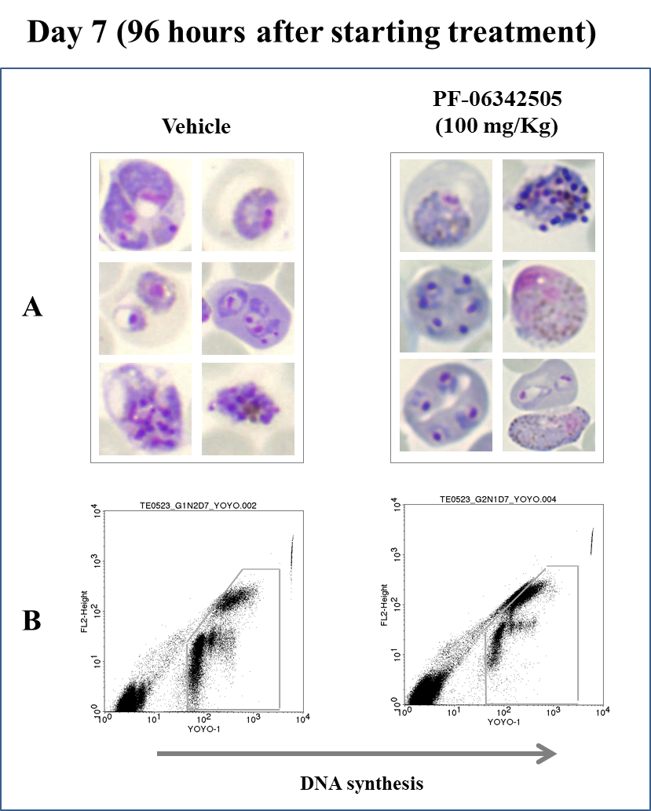

## Table 1. Summary efficacy data.

|  |  |  |  |  |  |
| --- | --- | --- | --- | --- | --- |
| **Parasite** | **Compound** | **Target Dose (mg/Kg)** | **Mouse** | **% Parasitemia at day 7 after infection** | **AUC(0-23h)**  **(µg·h·ml-1)** |
| *P. berghei* | Vehicle | 0 | 1 | 12.95 | 0 |
| *P. berghei* | Vehicle | 0 | 2 | 14.92 | 0 |
| *P. berghei* | PF-06342505 | 100 | 1 | 7.74 | 16.5 |
| *P. berghei* | PF-06342505 | 100 | 2 | 10.33 | 17.44 |
| *P. berghei* | PF-06342505 | 100 | 3 | 17.21 | 18.78 |
| *P. falciparum\** | PF-06342505 | 100 | 7 | < 0.01 | 15.34 |

(*): Data from the study 1607_TPG_071

**Laboratory Practice and Animal Management Observed by**

**The Malaria Support Group**

All GlaxoSmithKline-Tres Cantos staff involved in animal research are trained to standards which are approved by recognised professional bodies and which adhere to national guidelines. Animals are transported, housed and cared for by dedicated staff. All due measures are taken to prevent or minimise pain and distress during and after experimental procedures. The Company supervises all staff appropriately and provides suitable facilities so that staff can carry out their duties responsibly and humanely. Qualified veterinarians are available at all times for advice and help in the care of animals and in the conduct of the research. In this study, all involved scientific staff followed GlaxoSmithKline’s ethical code of practice for the care and use of experimentation animals.

GlaxoSmithKline-Tres Cantos animal facilities and R&D programmes comply with all national and European Union laws, guidelines and codes of conduct for animal care and research use. In addition, GlaxoSmithKline-Tres Cantos animal facilities possess an independent accreditation of animal care by the [**Association for Assessment and Accreditation of Laboratory Animal Care**](http://www.aaalac.org/) **International**(AAALAC). AAALAC certifies that GlaxoSmithKline-Tres Cantos follows the highest standards in management programs that permit animals to grow, mature, reproduce, and maintain good health; provide for their well-being; and minimize variations that can affect research results.

The rodents used to conduct this study were obtained from internationally respected animal suppliers, namely Charles River Labs and Harlan. The animals have been bred specifically for research and were certified to be specific pathogen-free.

In order to ensure animal well-being, as well as experimental reproducibility, GlaxoSmithKline-Tres Cantos periodically and accurately monitors the physical microenvironment and macroenvironment parameters of its animal facilities. These parameters include (but are not limited to) **housing** and **space recommendations**, **temperature**, **humidity**, **ventilation** and **air pressure**, **sterilization by hydrogen peroxide vapor**, **illumination pattern**, **noise**, **food**, **water**, **bedding**, **sanitation**, **waste** **disposal**, and **pest** **control**.

During the conduction of the present Study no abnormal measurements of the aforementioned environmental parameters occurred which could affect the reliability of the data obtained.